BookNest
MERN Stack Online Book Store
Project Documentation
Developed By: K. Suhana
B.Tech – Computer Science & Engineering
Repository: github.com/kammurusuhana/BookNest

Table of Contents
Table of Contents 1
1. Introduction 1
2. Project Overview 1
Purpose 1
Features 1
3. Architecture 1
4. Setup Instructions 1
Commands 1
5. Folder Structure 1
6. Running the Application 1
7. API Documentation 1
8. Authentication 1
9. User Interface 1
User Pages 1
Seller Pages 1
Admin Pages 1
10. Testing 1
11. Screenshots / Demo 1
12. Known Issues 1
13. Future Enhancements 1
References 1

1. Introduction
Project Title: BookNest
Team Lead: K. Suhana
BookNest is a MERN-based online bookstore with User, Seller, and Admin modules. It is a full-stack web application developed using MongoDB, Express.js, React.js, and Node.js, allowing users to browse and purchase books, sellers to manage their inventory, and administrators to oversee the entire platform.

2. Project Overview

Purpose
Build a role-based bookstore platform that supports three distinct types of users: buyers (Users), inventory owners (Sellers), and platform managers (Admins), each with tailored dashboards and permissions.

Features
- Book browsing
- wishlist management
- order placement and tracking
- seller inventory management
- admin-level platform management.

3. Architecture
Frontend: React.js, React Router DOM, Axios, HTML5, Inline CSS
Backend: Node.js + Express.js
Database: MongoDB with Mongoose
Other Packages: Multer (image upload), CORS, Dotenv
The application follows a client-server architecture. The React.js frontend communicates with the Express.js/Node.js backend via REST APIs (using Axios), and the backend interacts with a MongoDB database through Mongoose for data persistence.

4. Setup Instructions
- Install Node.js and MongoDB on your local machine.
- Clone the repository from GitHub.
- Run npm install inside both the client and server directories.
- Configure the .env file with required environment variables.
- Start the backend and frontend applications.

Commands
# Clone the repository
git clone https://github.com/kammurusuhana/BookNest.git
# Install backend dependencies
cd server
npm install
# Install frontend dependencies
cd client
npm install

5. Folder Structure
BookNest
│
├── client
│ ├── Admin
│ ├── Seller
│ ├── User
│ ├── Components
│ ├── api.js
│ └── App.jsx
│
├── server
│ ├── config
│ ├── controllers
│ ├── middlewares
│ ├── models
│ ├── routes
│ ├── uploads
│ └── server.js
│
└── README.md
client/ contains the React application, organized by role (Admin, Seller, User) along with shared Components and the central api.js file for API calls.
server/ contains the Express backend, organized into config, controllers, middlewares, models, routes, and an uploads directory for images.

6. Running the Application
Backend: npm start (or node server.js)
Frontend: npm run dev
Ensure MongoDB is running locally (or that a valid MongoDB Atlas connection string is configured) before starting the backend server.

7. API Documentation
The backend exposes REST APIs, returning JSON, that cover the following functional areas:
- Authentication — registration and login for Users, Sellers, and Admins
- Books — create, read, update, and delete book listings
- Wishlist — add and remove books from a user's wishlist
- Orders — place orders and retrieve order details/history
- Seller — seller inventory and order management endpoints
- Admin — user/seller management and platform monitoring endpoints
- Users — profile and account-related endpoints

8. Authentication
BookNest implements role-based login for three user types: User, Seller, and Admin. Routes are protected using authorization middleware that verifies the requester's role before granting access to role-specific resources (e.g., a Seller cannot access Admin-only endpoints, and vice versa).

9. User Interface
The application provides responsive pages tailored to each role:

User Pages
- Home

- Books and book details
- Wishlist
- My Orders and order details
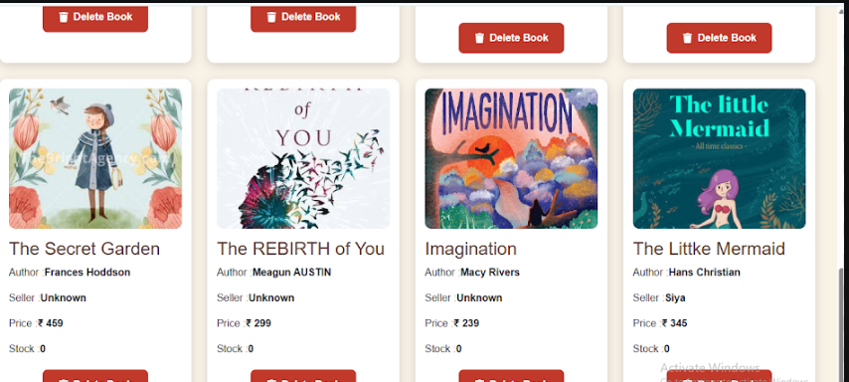

Seller Pages
- Dashboard
- Add Book
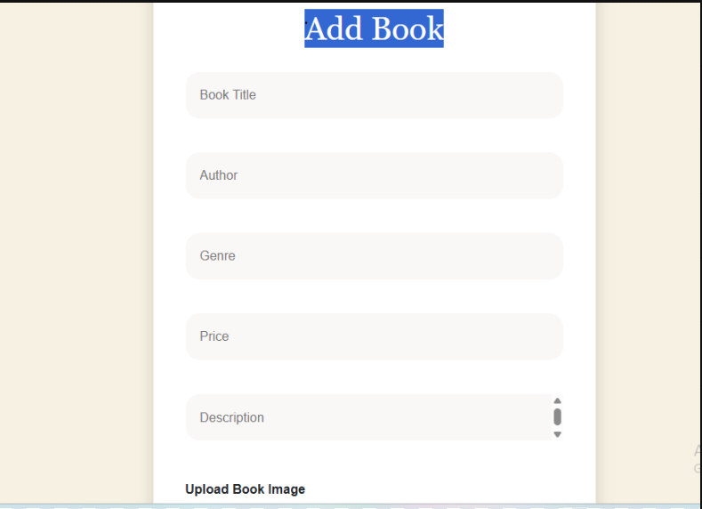
- My Products
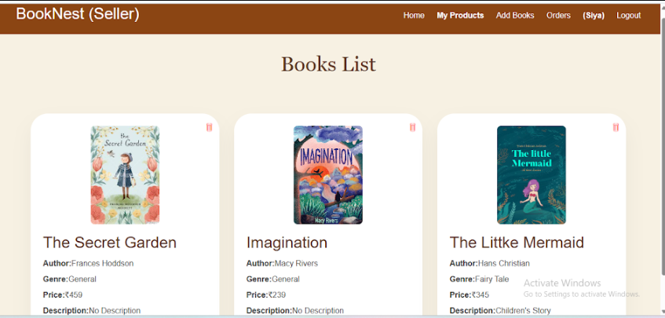

Admin Pages
- Registration and Dashboard
- Users
- Sellers
- Books
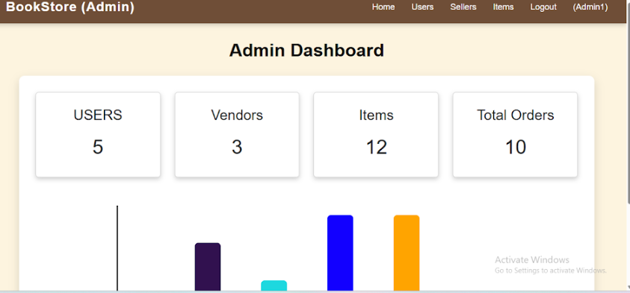
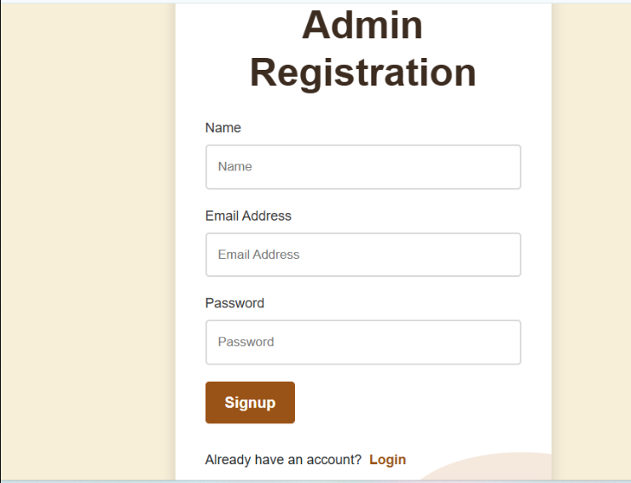

10. Testing
Functional, integration, and manual testing were performed across the following areas:
- Login and role-based authentication for User, Seller, and Admin
- CRUD operations for books and wishlist items
- Order placement and order detail retrieval
- Dashboard functionality for Seller and Admin modules

11. Screenshots / Demo
[Add screenshots of the following pages]
- Home Page
- Login Page
- Seller Dashboard
- Admin Dashboard
- Orders Page
- Book Details Page

12. Known Issues
- No payment gateway integration yet
- Limited search and filtering capability
- Basic authentication (JWT not yet implemented)
- Mobile responsiveness can be improved

13. Future Enhancements
- JWT-based authentication
- Online payment gateway integration
- Book ratings and reviews
- Email notifications
- Order tracking
- Sales analytics for Admin/Seller dashboards
- AI-based book recommendations
- Improved mobile-responsive UI

References
- React.js Documentation — https://react.dev
- Node.js Documentation — https://nodejs.org/docs
- Express.js Documentation — https://expressjs.com
- MongoDB Documentation — https://www.mongodb.com/docs
Developed by K. Suhana, B.Tech – Computer Science & Engineering.
This project is developed for educational and academic purposes only.

